*ECE 1000 Final Report: Automatic Plant Watering System*

Alex Stewart, John Bryson

Tennessee Technological University

Department of Electrical and Computer Engineering

Cookeville, TN, USA

[abstewart43@tntech.edu](mailto:abstewart43@tntech.edu), [jbryson42@tntech.edu](mailto:jbryson42@tntech.edu)

***Abstract-* The "Automatic Plant Watering System Using Raspberry Pi Pico" is designed to simplify plant care by ensuring optimal soil moisture levels through automation. Utilizing a Raspberry Pi Pico microcontroller, this system integrates soil moisture sensors and a water pump to deliver precise irrigation based on real-time sensor feedback. This project was motivated by the growing need for efficient and automated gardening solutions for busy individuals. Results showed reliable performance in maintaining appropriate soil moisture, with room for further enhancements in scalability and energy efficiency.**

**Keywords—Raspberry Pi Pico, Soil Moisture Sensor, Automation, Microcontroller, Smart Irrigation**

1. Introduction

With the increasing demand for automated solutions in everyday life, our team developed an "Automatic Plant Watering System" that uses a Raspberry Pi Pico microcontroller. This project is significant because it reduces the risk of overwatering or underwatering plants, a common issue for those with busy schedules or minimal gardening experience.

Team members:

* Alex Stewart, Maintenance Engineering Technology
* John Bryson, Electrical Engineering

The following sections detail the project's background, design, implementation, results, and conclusions.

1. Background

The concept and implementation of this project were informed by a tutorial on Instructables titled "[Automatic Raspberry Pi Pico W Watering System](https://www.instructables.com/Automatic-Raspberry-Pico-W-Watering-System/)". This guide provided an overview of hardware connections, programming principles, and best practices for building a smart irrigation system. Additional resources included Raspberry Pi Pico documentation and online forums for troubleshooting and optimization.

All references were thoroughly reviewed to ensure proper credit and effective learning for the team’s implementation.

1. Project Description and Formulation

This system uses a Raspberry Pi Pico microcontroller to automate watering based on soil moisture levels. Key components include:

* **Soil moisture sensor**: Measures real-time soil moisture levels.
* **Water pump**: Delivers water when the soil is too dry.
* **Raspberry Pi Pico**: Controls the system using a programmed algorithm.
* **Power supply**: Powers all components.

#### **Circuit Connections**

* Soil moisture sensor connected to ADC pins on the Raspberry Pi Pico.
* Water pump controlled via a relay module, linked to GPIO pins.
* A 5V power supply provides power to both the Raspberry Pi Pico and the water pump.

#### **Code Functionality**

The code reads moisture levels from the sensor and compares them to a threshold value. If the moisture falls below the threshold, the pump activates for a set duration. The system then pauses to allow water to absorb into the soil, ensuring efficiency.

**System Diagram**

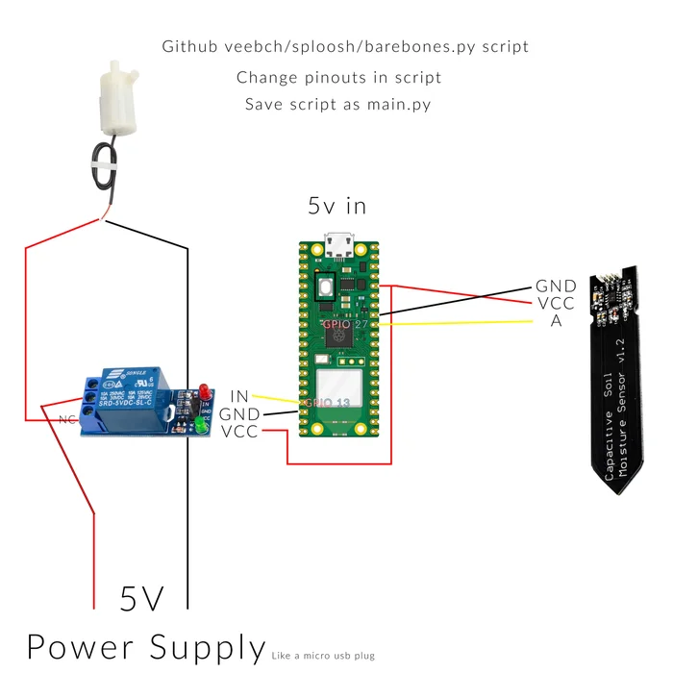

**System Image**

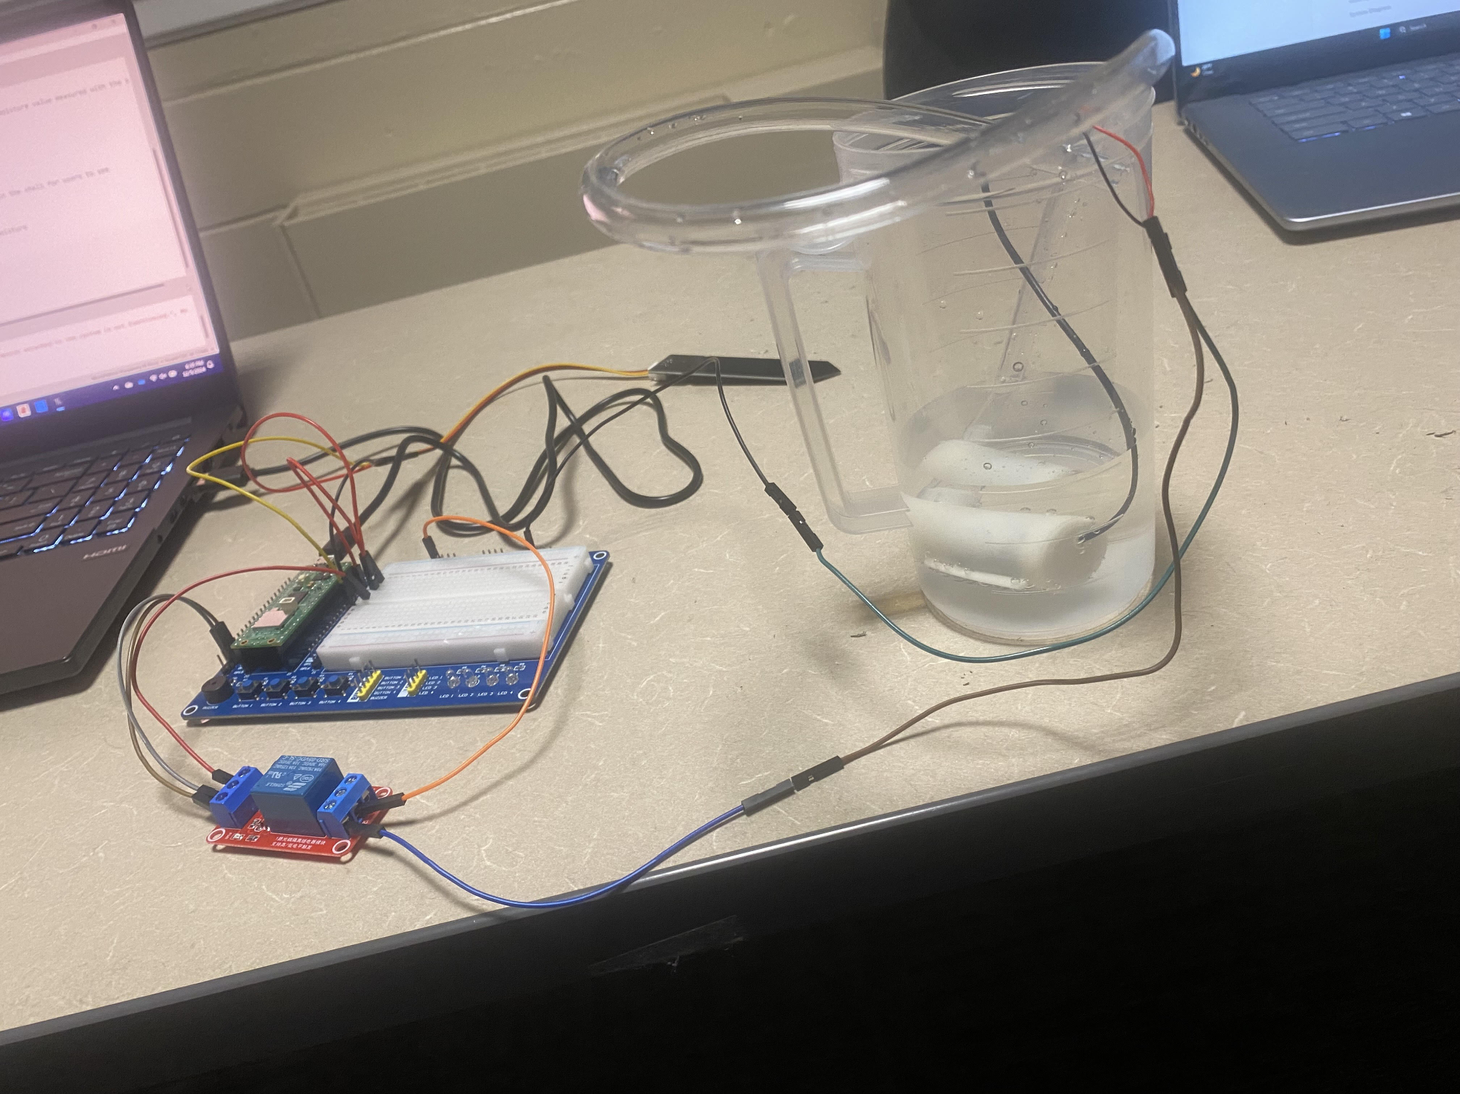

1. Discussion and Results

The system successfully maintained soil moisture within desired thresholds during testing. Notable observations:

* The water pump operated reliably without overwatering or underperforming.
* The soil moisture sensor provided accurate readings, although performance varied slightly in extreme soil conditions.

**Potential Improvements:**

* Add a larger water reservoir for extended operation.
* Introduce solar power for sustainability.
* Enhance the interface with smartphone connectivity for remote monitoring.

**Team Contributions:**

* Alex Stewart,John Bryson : Circuit assembly and wiring.
* John Bryson: Coding and algorithm development.
* Alex Stewart: Documentation and presentation preparation.

1. Conclusion

The Automatic Plant Watering System project demonstrates how simple automation can address everyday problems like inconsistent plant care. The project allowed team members to develop skills in microcontroller programming, circuit design, and problem-solving. The results indicate the system's practicality for small-scale use, with promising avenues for future enhancement.

References

[1] Collin Chidiac “Automatic Raspberry Pico W Watering System” <https://www.instructables.com/Automatic-Raspberry-Pico-W-Watering-System/>

[2] JC Williams “ECE_1000_Soil_Moisture_Sensor_Example.py” <https://github.com/JCWilliams1003/ECE-1000-Spring-2024-Final-Project-Insert-Project-Name>